**Generating a Certificate Signing Request (CSR) Using OpenSSL on Windows**

**Objective**

This class activity aimed to generate a Certificate Signing Request (CSR) using OpenSSL on a Microsoft Windows system. This process is essential for creating a secure connection between a web server and a client by ensuring that a trusted certificate authority (CA) can authenticate the server's identity.

**Introduction**

A Certificate Signing Request (CSR) is a block of encoded text given to a Certificate Authority when applying for an SSL Certificate. It contains information such as the organization name, domain name, locality, and country. Generating a CSR is the first step in obtaining an SSL certificate, which is necessary for encrypting data transmitted over the internet.

This activity involved using OpenSSL, a robust and full-featured toolkit for the Transport Layer Security (TLS) and Secure Sockets Layer (SSL) protocols, as well as a general-purpose cryptography library. The steps included installing OpenSSL, generating a private key, and creating a CSR that encapsulates the necessary information for certificate enrollment.

**Class Activity**

**Environment:**

* Operating System: Microsoft Windows 10
* OpenSSL Version: OpenSSL-Win32

**Commands Executed:**

cd \Program Files (x86)\OpenSSL-Win32\bin

openssl genrsa -out private-key.key 2048

openssl req -new -key private-key.key -out csr.txt

**User Input:**

* Country Name: KE
* State or Province Name: Nairobi
* Locality Name: Nairobi
* Organization Name: USIU
* Organizational Unit Name: APT3090
* Common Name: nairobi.com

**File Management:**

md c:\certificate

move private-key.key c:\certificate

move csr.txt c:\certificate

notepad c:\certificate\csr.txt

**Observations**

* Successfully generated a private key and CSR.
* The csr.txt file contains the required information for certificate enrollment.
* Proper directory management was performed to store the generated files.

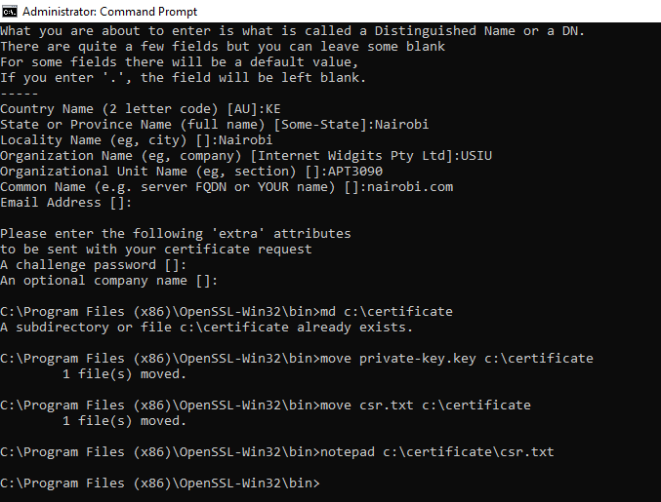

A new window (i.e. Notepad) opened which contains the information needed to enroll for a certificate as shown below

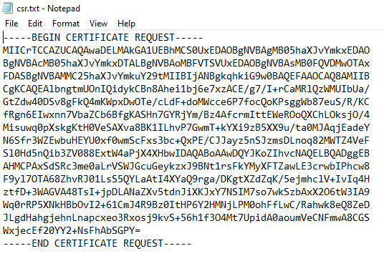

**Conclusion**

This activity demonstrated the process of generating a CSR using OpenSSL on a Windows system, which is a crucial step for securing web servers with SSL certificates. The detailed commands and user inputs provided a clear pathway to create and manage cryptographic keys and requests efficiently.